Online grievance redressal system
Objective:
Online grievance redressal system is an online application where people can share ideas, invoke discussions, issue complaints, create suggestion/petitions for improvement of city administration.
Users of the System:
- Admin
- Employee
- User
Functional Requirements:
- Users should be able to create new account, log-in to their existing accounts which will give them the authority to use the services provided by the system.
- Authenticated users should be able to issue complaints, check complaint status.
- Employee can log-in to their accounts as created by administrator.
- Employee can access all the complaints, suggestions from users.
- Give response to complaints with activity reports.
- Admin can Create, and monitor accounts of authorities

While the above ones are the basic functional features expected, the below ones can be nice to have add-on features:
- Online Surveys.
- Facility to upload photos of the complaint. for eg, garbage problem.
- Email integration for intimating new compliant.
- Multi-factor authentication for the sign-in process

Output/ Post Condition:
- Queries and responses answered report
- Escalation reports based on responsibility matrix
- Standalone application / Deployed in an app Container
- Monthly Report

Non-Functional Requirements:

Security | - App Platform –UserName/Password-Based Credentials  - Sensitive data has to be categorized and stored in a secure manner  - Secure connection for transmission of any data
Performance | - Peak Load Performance  - Online grievance redressal system -< 3 Sec  - Admin application < 2 Sec  - Non Peak Load Performance  - Online grievance redressal system < 2 Sec  - Admin Application < 2 Sec
Availability | - 99.99 % Availability
Standard Features | - Scalability  - Maintainability  - Usability  - Availability  - Failover
Logging & Auditing | - The system should support logging(app/web/DB) & auditing at all levels
Monitoring | - Should be able to monitor via as-is enterprise monitoring tools
Cloud | - The Solution should be made Cloud-ready and should have a minimum impact when moving away to Cloud infrastructure
Browser Compatible | - IE 7+  - Mozilla Firefox Latest – 15  - Google Chrome Latest – 20  - Mobile Ready

Technology Stack
Front End | React  Google Material Design  Bootstrap / Bulma
Server Side | Spring Boot  Spring Web (Rest Controller)  Spring Security  Spring AOP  Spring Hibernate
Core Platform | OpenJDK 11
Database | MySQL or H2

Platform Pre-requisites (Do’s and Don’ts):
- The React app should run in port 8081. Do not run the React app in the port: 3000.
- Spring boot app should run in port 8080.

Key points to remember:
- The id (for frontend) and attributes(backend) mentioned in the SRS should not be modified at any cost. Failing to do may fail test cases.
- Remember to check the screenshots provided with the SRS. Strictly adhere to id mapping and attribute mapping. Failing to do may fail test cases.
- Strictly adhere to the proper project scaffolding (Folder structure), coding conventions, method definitions and return types.
- Adhere strictly to the endpoints given below.

Application assumptions:
- The login page should be the first page rendered when the application loads.
- Manual routing should be restricted by using AuthGaurd by implementing the canActivate interface. For example, if the user enters as http://localhost:3000/signup or http://localhost:3000/home the page should not navigate to the corresponding page instead it should redirect to the login page.
- Unless logged into the system, the user cannot navigate to any other pages.
- Logging out must again redirect to the login page.
- To navigate to the admin side, you can store a user type as admin in the database with a username and password as admin.
- Use admin/admin as the username and password to navigate to the admin dashboard.

Validations:
- Basic email validation should be performed.
- Basic mobile validation should be performed.
Project Tasks:
API Endpoints:
USER
Action | URL | Method | Response
Login | /login | POST | true/false
Signup | /signup | POST | True/false
Add Compliant | /add Compliant | POST | Compliant added
List logged in user Compliant | /compliant/{id} | GET | Array of Compliant
Update Compliant | /compliant/{id} | PUT | Compliant Updated.
Update Status | /status/{id} | PUT | Status Updated.
ADMIN
Action | URL | Method | Response
Get All Compliant | /admin | GET | Array of Compliant
Add Employee | /admin/addEmployee | POST | Employee added
Update Employee | /admin/updateEmployee /{id} | PUT | Employee Updated
Delete Developer | /admin/deleteEmployee /{id} | DELETE | Delete Successful
Map Compliant | /admin/mapCompliant /{issueId} | POST | Save the Changes
Update Compliant | /admin/updateCompliant /{id} | PUT | Update Success
Get All Opened Status | /admin/openStatus | GET | Array of Status
Get All Closed Status | /admin/closedStatus | GET | Array of Status
Frontend:
Customer:
Login:
Output Screenshot:
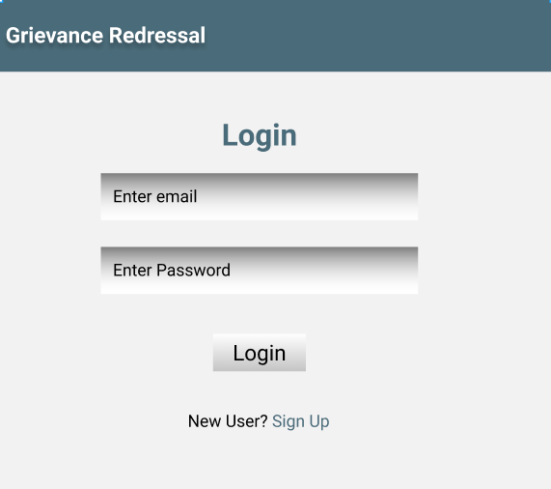

Signup:
Output Screenshot:
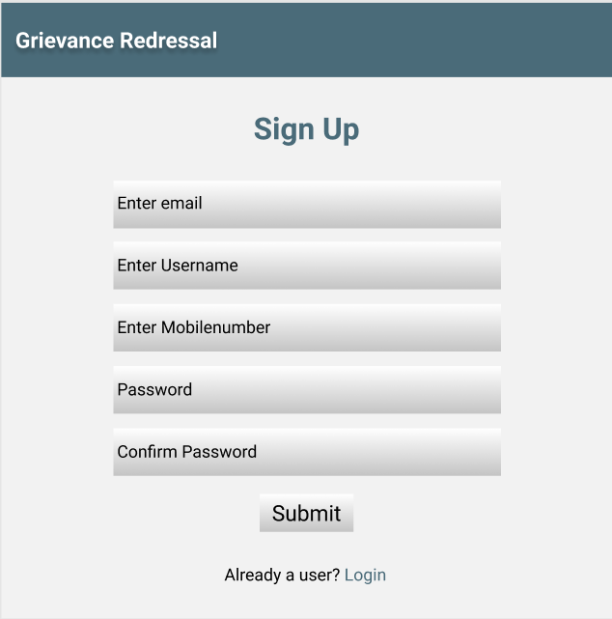
Home:
Output Screenshot:
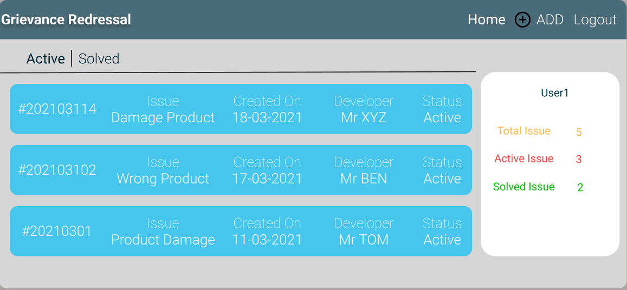

Add Issue:
Output Screenshot:
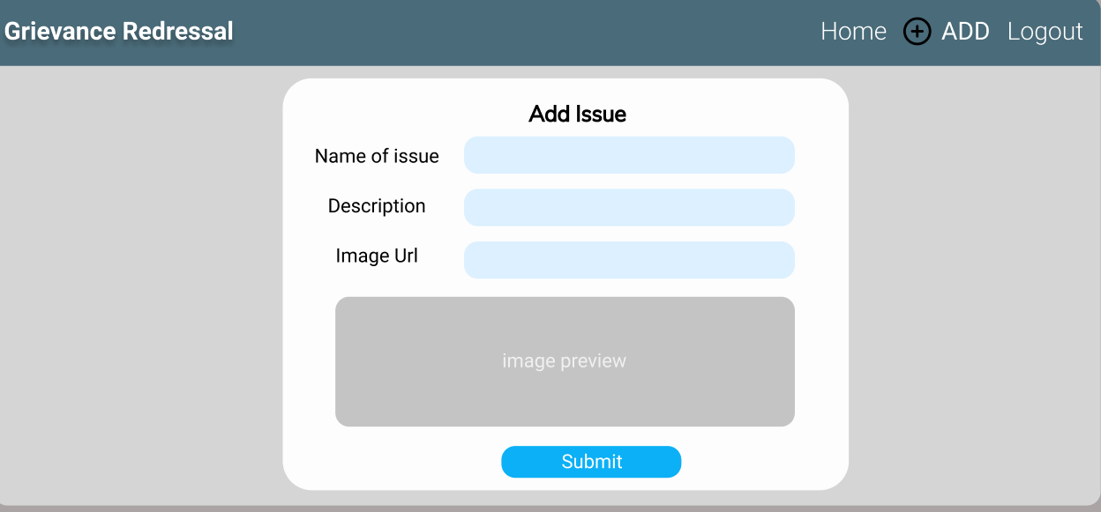

Developer:
Home:
Output Screenshot:
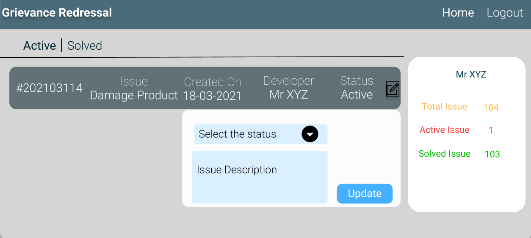

Admin:
Home:
Output Screenshot:
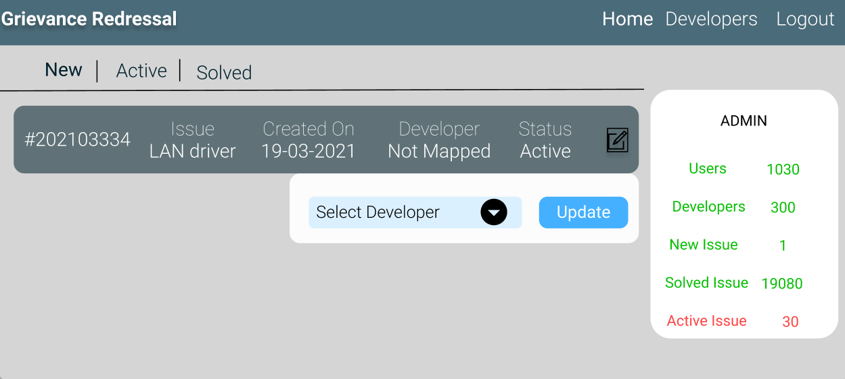

Manage User:
Output Screenshot:
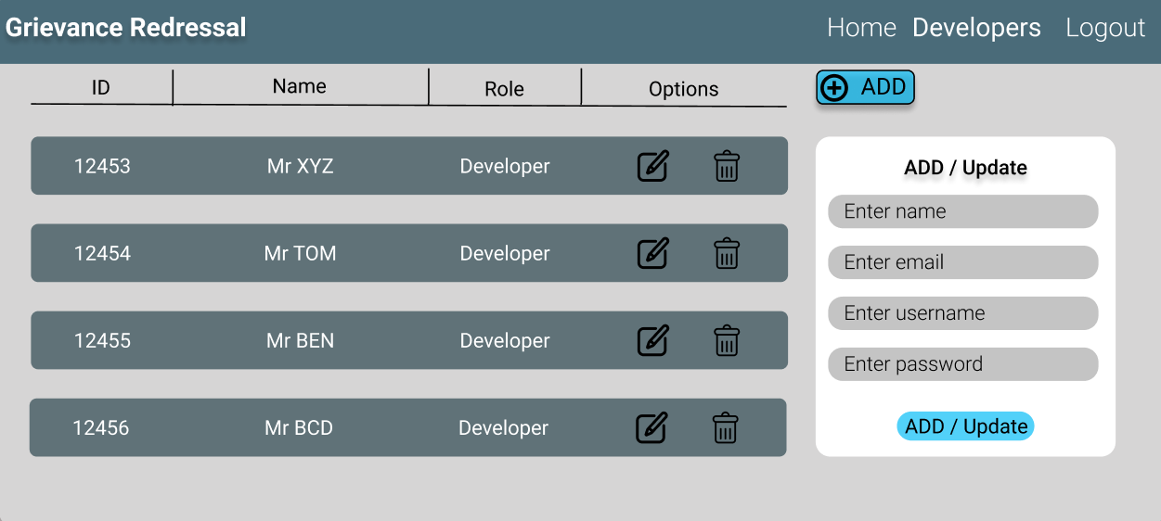

Backend:
Class and Method description:

Model Layer:

- UserModel: This class stores the user type (Admin or the Employee or the User) and all user information.
  - Attributes:
    - email: String
    - password: String
    - username: String
    - mobileNumber: String
    - active: Boolean
    - role: String
  - Methods: -

- LoginModel: This class contains the email and password of the user.
  - Attributes:
    - email: String
    - password: String
  - Methods: -

- CompliantModel: This class stores the details of the Issue.
  - Attributes:
    - compliantId: String
    - compliantName: String
    - createdOn: Date
    - createdBy: UserModel
    - resolvedBy: UserModel
    - status: StatusModel
  - Methods: -
- StatusModel: This is hold the Status of all the Issues.
a. Attributes:
- statusId: String
- status: String
- statusDesc: Desc
b. Methods: -
Controller Layer:
- SignupController: This class control the user signup
  - Attributes: -
  - Methods:
- saveUser(UserModel user): This method helps the user to create account in the database and return true or false based on the database transaction
- UserController: This calss controls the add/edit/update/view the users.
  - Attributes: -
  - Methods:
    - List<userModel> getUsers(): This method helps the admin to fetch all users from the database.
    - UserModel userDataById(String id): This method helps the admin to retrieve a user from the database based on the user id.
    - userEditSave(UserModel data): This method helps the admin to edit a user and save it to the database.
    - userSave(UserModel data): This method helps the admin to add a new user to the database.
    - UserDelete(UserDelete String id): This method helps the admin to delete a user from the database.
- LoginController: This class controls the user login.
  - Attributes: -
  - Methods:
    - checkUser(LoginModel data): This method helps the user to sign up for the application and must return true or false
- CompliantModel: This class controls the add/edit/update/view Issue.
  - Attributes: -
  - Methods:
    - List<CompliantModel > getIssue(): This method helps the admin to fetch all Compliant from the database.
    - List<CompliantModel> getHomeIssue(): This method helps to retrieve all the Compliant from the database.
    - CompliantModel IssueEditData(String id): This method helps to retrieve a Compliant from the database based on the Compliant Id.
    - compliantEditSave(CompliantModel data): This method helps to edit a Compliant and save it to the database.
    - compliantSave(CompliantModel data): This method helps to add a new Compliant to the database.
    - compliantDelete (String id): This method helps to delete a Compliant from the database.
- StatusController: This class helps to manage the open / closed issues.
  - Attributes: -
  - Methods:
    - mapCompliant(String compliantId): This method helps the map the issue with status.
    - List<StatusModel> showOpenStaus(): This method helps to view the all opened status
    - List<StatusModel> showClosedStaus(): This method helps to view the all Closed status.

